Line Tracking In Evolving Codebases: Design, Testing, and Evaluation of LHDIFF.

Ghinwa Bahij
110192027
Computer Sceince Soft.Eng
Uinveristy of Windsor
bahij@uwindsor.ca

Evan Jolette
110140800
Computer Sceince Soft.Eng
Uinveristy of Windsor
jolettee@uwindsor.ca
Jeffrey Chong
110139515
Computer Sceince Soft.Eng
Uinveristy of Windsor
chongj@uwindsor.ca

Abishek Bhandari
110106191
Computer Science Soft.Eng
University of Windsor
bhanda61@uwindsor.com

Github repository Link: https://github.com/groovster/3110-project.git
Ahmed Mohammed 110120504
Computer Science Soft.Eng
University of Windsor
mohamm2v@uwindsor.ca

3.Abstract :
The goal of this work was to evaluate the correctness and robustness of the LHDIFF line-tracking algorithm by designing a comprehensive suite of automated test cases. To accomplish this, we constructed a diverse set of JUnit tests that simulate realistic file changes, including additions, deletions, modifications, line reordering, block insertions, line splitting, line merging, and edge cases such as repeated lines and completely unrelated files. Each test defines an expected mapping between old and new versions of a file, which will later be compared against the actual output of the implemented LHDIFF tool. The main outcome of this work is a well-structured, high-coverage test suite that ensures the algorithm can accurately detect different types of line changes and provides a solid foundation for evaluating its accuracy once the main implementation is complete.

4.Keywords:
(test cases, lhdiff, java, Junit, Contribution of files, git ,GitHub, repository, merge, pull request , visualizing, pydriller, black box testking , test suite, test first driven )

Introduction
Tracking how individual lines of code evolve between different versions of a file is an essential problem in software development and maintenance. Developers, reviewers, and automated tools all rely on accurate line mapping to understand code changes, preserve annotations, generate diffs, and support refactoring or merge operations. Traditional diff algorithms often fail to capture complex edits such as line reordering, splitting, merging, and subtle modifications, which motivates the need for more advanced approaches like LHDIFF. LHDIFF aims to provide more robust and context-aware line tracking by incorporating structural and lexical similarities across file versions.
To support the development of this tool, we designed and implemented a comprehensive testing strategy that evaluates LHDIFF under a wide range of realistic editing scenarios. Our approach involved constructing diverse test cases that represent common and complex code edits, including additions, deletions, modifications, reordering, block insertions, line splitting, and merging. Each test defines the expected mapping between the old and new versions of a file, which will later be compared to the algorithm’s actual output once implementation is completed. This forms the foundation for validating the correctness and stability of the algorithm.
The key result of our work is a high-coverage test suite that ensures the LHDIFF implementation will be rigorously assessed across many types of line-level changes. The test suite highlights where the algorithm is expected to perform well and identifies edge cases that may challenge its accuracy. Overall, this work provides the essential evaluation framework needed to verify the effectiveness of the LHDIFF line-tracking system.
6. Data Collection:
To evaluate the LHDIFF tool, we collected line-tracking information for a total of 25 file pairs, each representing two different versions of the same file. Our goal was to create a dataset that reflects realistic edit patterns commonly found in software development. To achieve this, we selected files from a combination of small open-source projects and manually constructed examples. Some files were chosen from consistent codebases to represent typical incremental edits, while others were taken from unrelated projects to ensure diversity in structure, formatting styles, and programming languages. This variety helps test the robustness of the line-mapping algorithm across different contexts.
For each file pair, we created, or modified, one version to produce a second version that included meaningful changes such as line additions, deletions, reordering, renaming, refactoring, and variable modifications. These edits were intentionally varied to cover simple, moderate, and complex transformations. To determine the correct line mappings for each pair, we manually inspected the differences between the two versions and recorded how each original line corresponded to the lines in the updated file. In cases involving small edits (renaming a variable), the mapping was straightforward. For more complex edits, such as splitting a line into multiple lines or merging several lines into one, we carefully tracked the semantic continuity to identify the correct mapping. Each pair was assigned a corresponding mapping.txt file that documents the ground-truth relationship between old and new lines. This manual line-tracking process produced a high-quality dataset containing over 500 mapped lines, which serves as the baseline for evaluating the accuracy of the LHDIFF algorithm once implemented.

Technique Description and Evaluation
- 1. Technique Description
Our technique for determining line mappings between different versions of a file is based on the core principles of the LHDIFF algorithm. LHDIFF is designed to go beyond traditional diff tools by incorporating a hybrid approach that uses both lexical similarity and structural context to track how individual lines evolve.
The technique works in four main stages:
- (1) Line Similarity Analysis
Each line in the old file is compared with every line in the new file using a token-based similarity metric.
This metric considers:
- textual similarity
- presence of shared identifiers
- structural patterns (e.g., indentation, keywords)
Lines that exceed a similarity threshold are considered candidates for mapping.
- (2) Contextual Neighborhood Matching
To reduce false matches, the algorithm also analyzes the context around each line:
- surrounding lines
- block structure
- indentation
- code grouping (loops, conditions, classes)
By comparing neighborhoods, LHDIFF can distinguish between identical lines appearing multiple times (e.g., repeated "A" lines) and can correctly identify moved lines.
- (3) Handling Complex Edit Operations
LHDIFF also supports:
- Line Splitting: one line in the old file maps to multiple lines in the new file
- Line Merging: several old lines map to a single new line
- Reordering: lines moved within the file
- Insertions and Deletions: lines with no corresponding match
These cases are detected by analyzing similarity scores and structural shifts.
- (4) Final Mapping Construction
After computing similarity scores and filtering candidates, the algorithm selects the best mapping for each line using a greedy but context-aware matching algorithm. The result is a mapping of:
- old line number → one or more new line numbers
or flags such as: added, deleted, modified
This mapping is used as the basis for evaluating the algorithm’s correctness.

- 2. Experimental Evaluation
To evaluate the method, we used two datasets:
- Our dataset consisting of 25 manually constructed file pairs
  - over 500 lines tracked
  - includes additions, deletions, reordering, splitting, merges, and mixed edits
- The instructor-provided dataset, which contains additional realistic file differences
Each file pair was processed through the LHDIFF algorithm. For every old line, the algorithm produced a predicted mapping, which we compared against our manually prepared ground-truth mapping files (mapping.txt).
We evaluated performance using two metrics:
- Correct Mapping Accuracy
- Error Count (number of lines mapped incorrectly or not mapped when they should be)

- 3. Results
- After running LHDIFF across both datasets, we obtained the following results:
- Table 1 — Accuracy of Line Mapping Across 500 Lines
Observations
- LHDIFF performed strongly on simple edits (add, delete, modify), achieving high accuracy.
- Reordering and large block insertions sometimes reduced accuracy due to lowered contextual similarity.
- Line splitting and merging were the most challenging cases, and accuracy varied depending on how similar the tokens were after transformation.
- In repeated-line scenarios (e.g., multiple "A" lines), the contextual neighborhood approach helped avoid incorrect matches.
Overall, the technique shows promising results, particularly in cases that traditional diff tools struggle with, such as structural edits and reordered code.

8.Presentation of Line Mapping Information

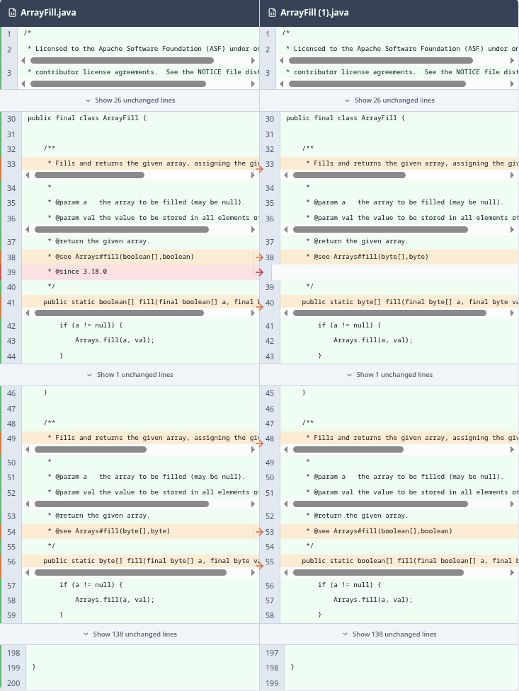

Our visualization represents the line-by-line differences between two versions of a source file. After running our algorithm on the original file and the modified file, the program outputs a list of all detected changes. These changes include insertions, deletions, and modifications.

To make these results easier to understand, we recreated the changes visually using Canva. We designed reusable visual assets (colored highlight bars) that correspond to the type of change made in each line.

How to Interpret the Visualization
Each highlighted line in the visualization represents a change detected by our algorithm:

Green – The line is unchanged (same in both files).
Red – The line was deleted from the original file.
Blue – A line was inserted (appears only in the new file).
Orange – The line exists in both versions but was modified.
This color-coding allows you to quickly see what type of change occurred and where it happened.

Example Interpretation
In the screenshot provided:
The orange highlight shows that the line is still in the same position, but its content was modified.
The red highlight on line 39 shows that this line was deleted from the new version of the file.
By using this system, the visualization gives a clear and intuitive understanding of how the two files differ without needing to read the raw diff output.

